Club membership application

The purpose of the project is to create a membership application for a sports club.

The application should be created in Visual Studio( .NET C# Web application), preferably 2015 version. All the project source code will be delivered with the application upon completing the project.

The design is not important, it can be the Visual Studio default, only important thing is that it is scalable to changing screen size(computer, laptop, tablet…)

# SQL Database model for the application

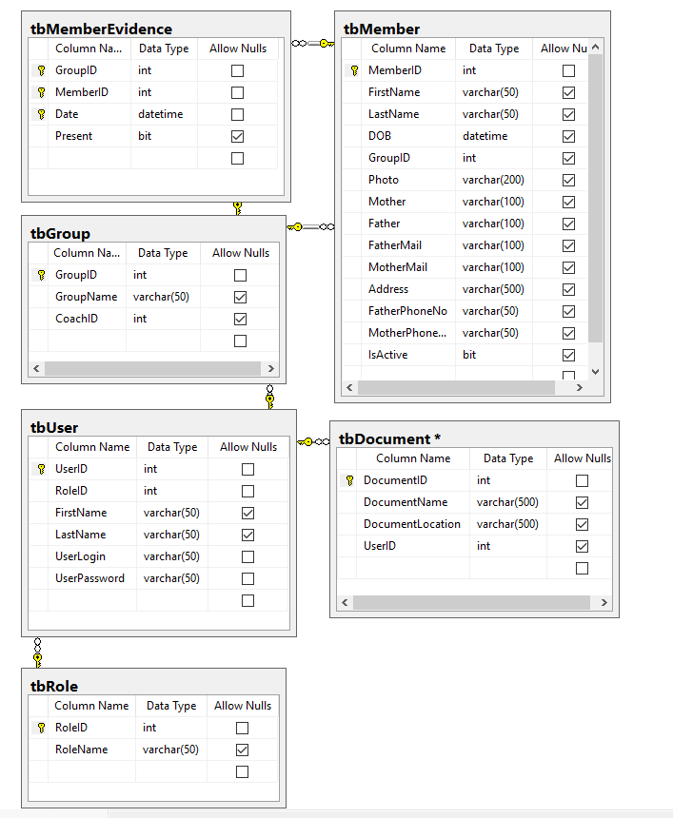

Database backup will be sent to the programmer.

The application will have 2 roles(in **tbRole**):

**Administrator**

**Coach**

Application will have a login page. Credentials are checked in the **tbUser** table.Depending on the user role, either the Administrator or the Coach interface is opened.

# Administrator

* Adds/Delete/Edit users to application(Coaches and Administrators) - **tbUser**
* Add groups to application and assign groups to Users with Coach role – **tbGroup** – CoachID is UserID from tbUser
* Adds/Delete/Edit members to application and assign members to Groups – **tbMember**
* Views/Adds/Deletes all documents in the application - **tbDocument**

# Coach

* Can edit the details for his user (**tbUser**) -> Name, Lastname, UserPassword
* Can view all documents/Add documets/Delete documents that he added (**tbDocument**).
* Can view the profile page of all members of his group(Name, Last Name, Birth Date, Photo, etc.. (fields from tbMember table))
* Interface to enter evidence for members in groups that are assigned to him(**tbMemberEvidence**)

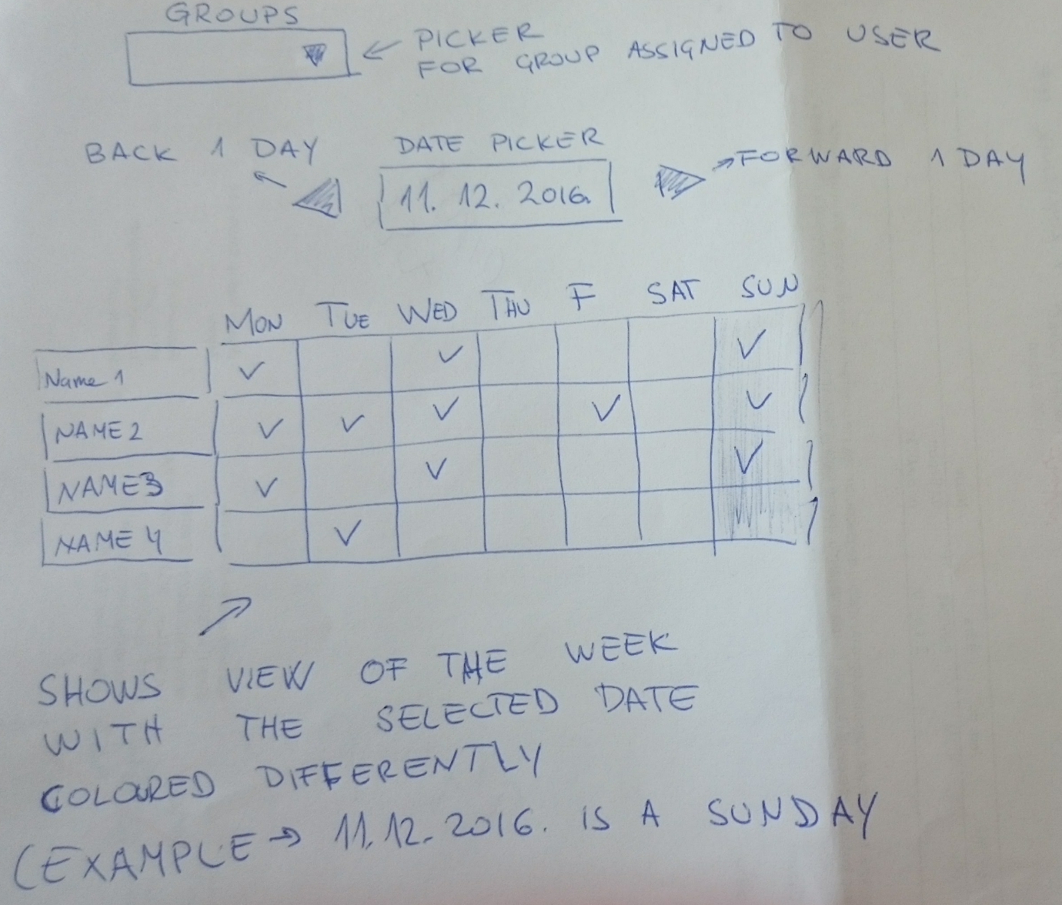

Evidence for memers is from the picture in the document.   
There would be a page called, for example "Member Evidence".  
The page contains a dropdown menu with all groups that are assigned to the who has the Coach role.  
Coach picks a group from the dropdown. That opens a view of attendance for all members of that group for the week selected in the date field.  
  
Coach can mark a field in the list, like checking attendance, meaning. on that date, that user was or was not present for practice.

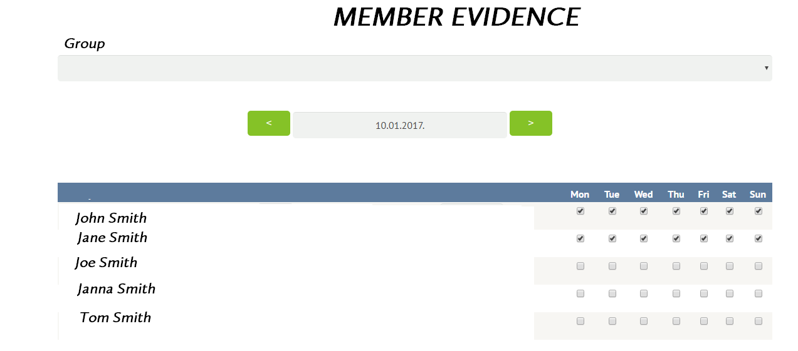

* A page with:

Group selector

Two date fields

A button that generates an Excel table with attendance percentage(field Present in **tbMemberEvidence**) between two selected dates.